**Database Migration**

Business Requirements Document (BRD)

Version 1

# Version and Approvals

**UTORS**

|  |  |
| --- | --- |
| **Version History** | |
| **Version #** | **Date** | | **Revised By** | **Reason for change** |
| **1** | **02/17/2022** | | **Jason Wu** | **Populating the template with currently known information** |
|  |  | |  |  |
|  |  | |  |  |
|  |  | |  |  |

This document has been approved as the official Business Requirements Document for the Database Migration and accurately reflects the current understanding of business requirements. Following approval of this document, requirement changes will be governed by the project’s change management process, including impact analysis, appropriate reviews and approvals.

|  |  |
| --- | --- |
| **Document Approvals** | |
| **Approver Name** | **Project Role** | | **Signature/Electronic Approval** | **Date** |
|  |  | |  |  |
|  |  | |  |  |
|  |  | |  |  |
|  |  | |  |  |

**Table of Contents**

Project Details 1

Overview 1

Document Resources 1

Glossary of Terms 1

Project Overview 1

4.1 Project Overview and Background 1

4.2 Project Dependencies 2

4.3 Stakeholders 2

Key Assumptions and Constraints 2

5.1 Key Assumptions and Constraints 2

Use Cases 2

Use Case Diagram 2

Use Case Narrative 3

Business Requirements 5

Appendixes 7

Appendix A – Business Process Flows 7

Appendix B – Business Rules Catalog 10

Appendix C- Models 10

Traceability Matrix 10

Use Case Narrative Instructions 10

Project Details

|  |  |
| --- | --- |
| **Project Name** | Database Migration from Access to Sharepoint |
| **Project Type** | New Initiative |
| **Project Start Date** | 02/11/2022 |
| **Project End Date** | 05/24/2022 |
| **Project Sponsor** | Maddalena Romano, Bill Harrison |
| **Primary Driver** | Efficiency |
| **Secondary Driver** |  |
| **Division** |  |
| **Project Manager/Dept** | Jason Wu, Hyunsoo Lee |

Overview

This document defines the high level requirements for the Database Migration. It will be used as the basis for the following activities:

* Creating solution designs
* Developing test plans, test scripts, and test cases
* Determining project completion
* Assessing project success

Document Resources

| **Name** | **Business Unit** | **Role** |
| --- | --- | --- |
| Maddalena Romano | NYC Department of Transportation, Office of Asset Management | Provided overview of business requirements for the project |
| Bill Harrison | NYC Department of Transportation, Traffic Operations | Provided some specific business requirements |
|  |  |  |
|  |  |  |
|  |  |  |

Glossary of Terms

| **Term/Acronym** | **Definition** |
| --- | --- |
| <Identify any terms and acronyms used within this document> |  |
|  |  |
|  |  |
|  |  |
|  |  |

Project Overview

## 4.1 Project Overview and Background

<**This information can be taken from the Project Charter**. This is a brief description of what the project is about. It includes the current situation, the problem and the objectives. This section serves as the vision statement for the requirements. Each requirement should bring the project closer to the vision.>

The current Access database that DOT Traffic Operations uses to keep track of streetlight information makes use of several large and redundant files, requires regular, manual, and dedicated maintenance, has a user-unfriendly interface, and is slow to respond to user input due to the size of the files. DOT Traffic Operations uses the current database to keep track of traffic related hardware such as streetlights and crossing signals. The deliverables of this project will resolve existing shortcomings in the system currently in use by DOT Traffic Operations.

The project intends to migrate the contents of the Access database to a more centralized database. The new database will have superior response times to user input, require less maintenance, and provide for a more user-friendly interface. The project will streamline existing Traffic Operations tasks, allow Traffic Ops employees to track assets more efficiently, and allow employees to make policies based on more readily accessible information on these assets.

The project expects to deliver a database containing the data previously stored in the Access database accompanied by a reworked web-based user interface.

## 4.2 Project Dependencies

This project has no known dependencies.

## 4.3 Stakeholders

The following comprises the internal and external stakeholders whose requirements are represented by this document:

|  | **Stakeholders** |
| --- | --- |
| 1. | Maddalena Romano |
| 2. | Bill Harrison |
| 3. |  |

Key Assumptions and Constraints

## 5.1 Key Assumptions and Constraints

|  |  |
| --- | --- |
| **#** | **Assumptions** |
|  | List any assumptions the requirements are based on |
|  |  |
|  |  |
|  |  |
|  |  |
|  |  |
| **#** | **Constraints** |
|  | List any constraints the requirements are based on |
|  |  |
|  |  |
|  |  |
|  |  |
|  |  |

Use Cases

< The primary purpose of the Use Case is to capture the required system behavior from the perspective of the end-user in achieving one or more desired goals. A Use Case contains a description of the flow of events describing the interaction between actors and the system. The use case may also be represented visually in UML in order to show relationships with other the use cases and actors>.

## Use Case Diagram

## 

## Use Case Narrative

<Each Use Case should be documented using this template. Refer to the Appendix for Use Case Narrative instructions>

|  |  |  |  |
| --- | --- | --- | --- |
| Use Case ID: | 1 | | |
| Use Case Name: | Access Database | | |
| Created By: | Jason Wu | Last Updated By: |  |
| Date Created: | 02/17/2022 | Date Last Updated: |  |

|  |  |
| --- | --- |
| Actors: | User |
| Description: | This use case describes the main way the new database will be used by a hypothetical DOT Traffic Ops employee. The user accesses the appropriate webpage and interacts with the user interface. |
| Preconditions: | Web browser opened and navigated to the front-end webpage |
| Postconditions: |  |
| Normal Course: | 1: Open browser  2: Navigate to the webpage  3: Interact with the interactive map and available data points using available functionality |
| Alternative Courses: | None |
| Exceptions: | None |
| Includes: |  |
| Priority: | High |
| Frequency of Use: | Once per visit |
| Business Rules | TBD |
| Special Requirements: | Accessible at all times  Response time comparable to Google Maps or other similar online mapping solutions |
| Assumptions: |  |
| Notes and Issues: |  |
| Use Case Graphic: See wireframe image on the next page. | |

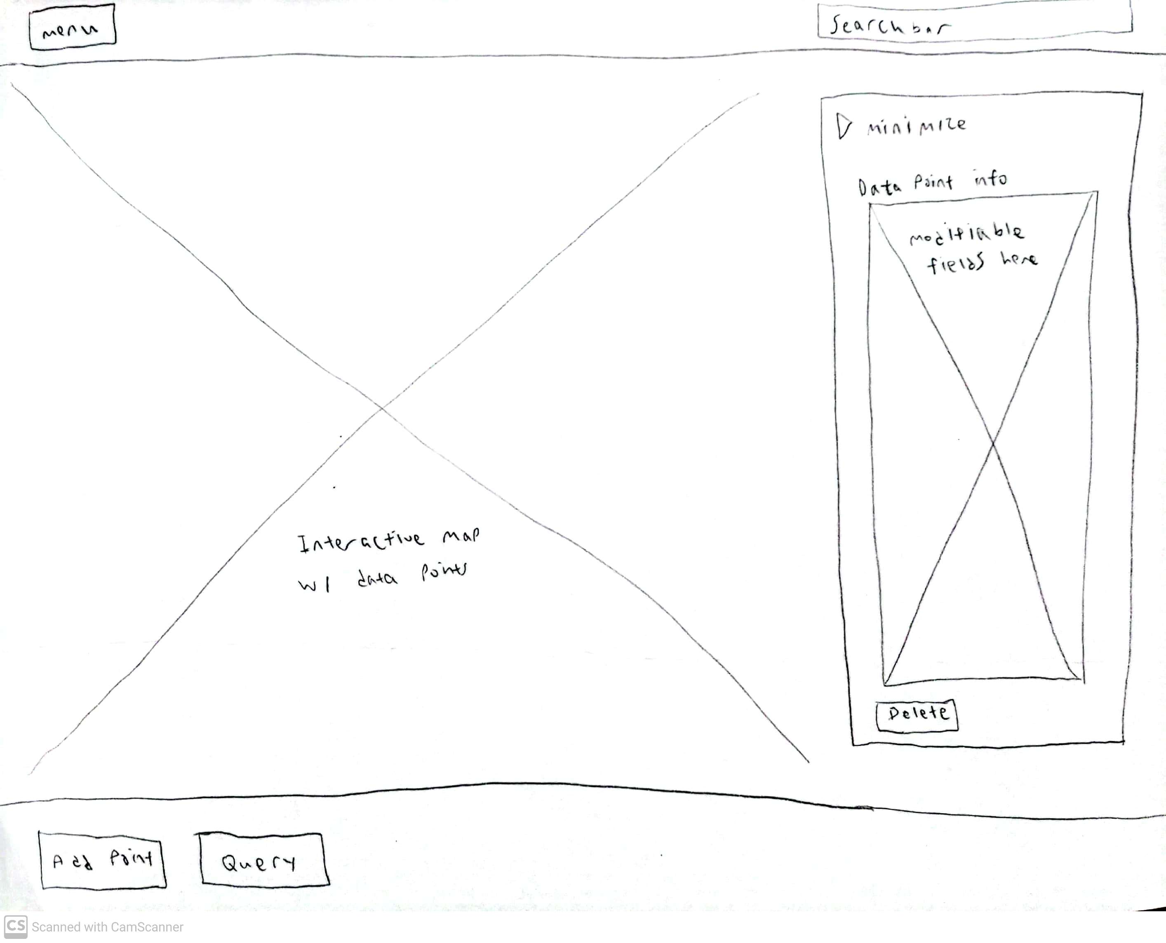

Business Requirements

The following sections document the various business requirements of this project. Please use the existing template to document

|  |  |  |  |  |  |  |  |  |  |
| --- | --- | --- | --- | --- | --- | --- | --- | --- | --- |
| Requirement Type | ID – Prefix ?? | ID – Number | Function – Feature - Requirement | Use Case Reference | Required | **??** | **??** | **??** | Comments |
|  | Business User Requirements | | | | | | | | |
|  | f | 0001 | Function: The new front-end UI must allow the user to add, modify, and remove data points. |  |  |  |  |  |  |
|  | f | 0002 | Function: The new front-end UI must contain an interactive map with data points and a dashboard overlayed on the map. |  |  |  |  |  |  |
|  | f | 0003 | Function: The front-end UI must allow the user to query information from the database. |  |  |  |  |  |  |
|  | f | 0004 | Feature: The database must have an accompanying data dictionary in order to document the purpose of all fields. |  |  |  |  |  |  |
|  | F | 0005 | Requirement: The contents of the old Access database must be transferred to a new database. |  |  |  |  |  |  |
|  | F | 0007 | Requirement: The data points in the new database must be centralized into one file. |  |  |  |  |  |  |
|  | f | 0007 |  |  |  |  |  |  |  |
|  | f | 0008 |  |  |  |  |  |  |  |
|  | Reporting, Data Requirements | | | | | | | | |
|  | f | 0001 |  |  |  |  |  |  |  |
|  | f | 0002 |  |  |  |  |  |  |  |
|  | f | 0003 |  |  |  |  |  |  |  |
|  | f | 0004 |  |  |  |  |  |  |  |
|  | F | 0005 |  |  |  |  |  |  |  |
|  | F | 0007 |  |  |  |  |  |  |  |
|  | f | 0007 |  |  |  |  |  |  |  |
|  | f | 0008 |  |  |  |  |  |  |  |
|  | Security, Access Control, and Compliance Requirements (Includes roles, user access needs) | | | | | | | | |
|  | f | 0001 |  |  |  |  |  |  |  |
|  | f | 0002 |  |  |  |  |  |  |  |
|  | f | 0003 |  |  |  |  |  |  |  |
|  | f | 0004 |  |  |  |  |  |  |  |
|  | F | 0005 |  |  |  |  |  |  |  |
|  | F | 0007 |  |  |  |  |  |  |  |
|  | f | 0007 |  |  |  |  |  |  |  |
|  | f | 0008 |  |  |  |  |  |  |  |
|  | Service Level Requirements (Includes Service Level, Scalability, and Performance) | | | | | | | | |
|  | f | 0001 |  |  |  |  |  |  |  |
|  | f | 0002 |  |  |  |  |  |  |  |
|  | f | 0003 |  |  |  |  |  |  |  |
|  | f | 0004 |  |  |  |  |  |  |  |
|  | F | 0005 |  |  |  |  |  |  |  |
|  | F | 0007 |  |  |  |  |  |  |  |
|  | f | 0007 |  |  |  |  |  |  |  |
|  | f | 0008 |  |  |  |  |  |  |  |
|  | Support and Maintenance Requirements | | | | | | | | |
|  | f | 0001 |  |  |  |  |  |  |  |
|  | f | 0002 |  |  |  |  |  |  |  |
|  | f | 0003 |  |  |  |  |  |  |  |
|  | f | 0004 |  |  |  |  |  |  |  |
|  | F | 0005 |  |  |  |  |  |  |  |
|  | F | 0007 |  |  |  |  |  |  |  |
|  | f | 0007 |  |  |  |  |  |  |  |
|  | **f** | **0008** |  |  |  |  |  |  |  |

Appendixes

## Appendix A – Business Process Flows

<Describe the current existing process workflow using flow diagrams (i.e. Visio Flowcharts) and/or a detailed narrative.>



### *As Is Diagrams*

<Insert As Is Diagrams here (if applicable)>

*To Be Diagrams*

<Insert To Be Diagrams here (if applicable)>



## Appendix B – Business Rules Catalog

<Instructions: Use the following template for each business rule. >

|  |  |
| --- | --- |
| Business Rule Name: | <The name should give you a good idea about the topic of the business rule.> |
| Identifier | <Defines unique identifier.> *EXAMPLE: BR1* |
| Description | <Defines the rule in detail.> *EXAMPLE: “All employee labor is tracked, reported and billed in 15 minute increments.”* |
| Example | <(Optional) An example of the rule> |
| Source | <Source of the rule. E.g. stakeholder> |
| Related Rules | <List of related rules, to support traceability> |

## Appendix C- Models

<Insert models here>

## Traceability Matrix

<Insert traceability matrix here>

## Use Case Narrative Instructions

<Instructions for completing the Use Case Narrative are included here. Remove these instructions from the completed Business Requirements Document>.

| **Use Case Field Name** | **Definition** |
| --- | --- |
| Use Case ID | Give each use case a unique numeric identifier, in hierarchical form: X.Y. Related use cases can be grouped in the hierarchy. Functional requirements can be traced back to a labeled Use Case. |
| Use Case Name | State a concise, results-oriented name for the use case. These reflect the tasks the user needs to be able to accomplish using the system. Include an action verb and a noun. Some examples:   * View part number information. * Manually mark hypertext source and establish link to target. * Place an order for a CD with the updated software version |
| Created By | Include the name of the person who initially documented this Use Case. |
| Date Created | Enter the date on which the use case was initially documented |
| Date Last Updated | Enter the date on which the use case was most recently updated |
| Last Updated By | Include the name of the person who performed the most recent update to the use case description. |
| Actor | Enter the person or other entity external to the software system being specified who interacts with the system and performs use cases to accomplish tasks. Different actors often correspond to different user classes, or roles, identified from the customer community that will use the product. Name the actor(s) that will be performing this Use Case. |
| Description | Provide a brief description of the reason for and outcome of this use case, or a high-level description of the sequence of actions and the outcome of executing the Use Case. |
| Preconditions | List any activities that must take place, or any conditions that must be true, before the Use Case can be started. Number each precondition. Examples:   * User’s identity has been authenticated. * User’s computer has sufficient free memory available to launch task |
| Post conditions | Describe the state of the system at the conclusion of the use case execution. Number each post condition. Examples:   * Document contains only valid SGML tags. * Price of item in database has been updated with new value |
| Normal Course | Provide a detailed description of the user actions and system responses that will take place during execution of the use case under normal, expected conditions. This dialog sequence will ultimately lead to accomplishing the goal stated in the use case name and description. This description may be written as an answer to the hypothetical question, “How do I <accomplish the task stated in the use case name>?” This is best done as a numbered list of actions performed by the actor, alternating with responses provided by the system. |
| Alternative Courses | Document other, legitimate usage scenarios that can take place within this use case separately in this section. State the alternative course, and describe any differences in the sequence of steps that take place. Number each alternative course using the Use Case ID as a prefix, followed by “AC” to indicate “Alternative Course”. Example: X.Y.AC.1 |
| Exceptions | Describe any anticipated error conditions that could occur during execution of the use case, and define how the system is to respond to those conditions. Also, describe how the system is to respond if the use case execution fails for some unanticipated reason. Number each exception using the Use Case ID as a prefix, followed by “EX” to indicate “Exception”. Example: X.Y.EX.1 |
| Includes | List any other use cases that are included (“called”) by this use case. Common functionality that appears in multiple use cases can be split out into a separate use case that is included by the ones that need that common functionality. |
| Priority | Indicate the relative priority of implementing the functionality required to allow this use case to be executed. The priority scheme used must be the same as that used in the software requirements specification. |
| Frequency of Use | Estimate the number of times this Use Case will be performed by the actors per some appropriate unit of time. |
| Business Rules | List any business rules that influence this Use Case. |
| Special Requirements | Identify any additional requirements, such as nonfunctional requirements, for the use case that may need to be addressed during design or implementation. These may include performance requirements or other quality attributes. |
| Assumptions | List any assumptions that were made in the analysis that led to accepting this use case into the product description and writing the use case description. |
| Notes and Issues | List any additional comments about this use case or any remaining open issues or TBDs (To Be Determined) that must be resolved. Identify who will resolve each issue, the due date, and what the resolution ultimately is. |